TEAM CENTER APPLICATION
-Navigator
-PSM
-Organization
-Change Management

To be Searched
Structure of Team Center items
Forms
Datasets
Structure Manager
Revision Rules

TEAM CENTER INTERFACE
Components of Teamcenter interface
“Home Folder”
As soon as you login first time into Team Center 3 folders will be created:
-Home
-New Stuff
-Mail Box

Data Base Administration
Adding, removing and giving access to users can be done using organization module.
To do this you need Team Center DBA access (Data Base Administration)
If you don’t want to give access to other people, it can be done by using Hidden. It can also be used to hide certain modules. This is called as hidden perspective. The modules that need to be hidden can be added under hidden perspective preference.
One user can be a member of a multiple groups and can perform multiple roles.
Group and roles can be changed from user settings below Team Center toolbars.
Groups can have multiple sub groups.
Each group or sub group can have one or more roles.
Each role can contain one or more users.
Groups
Roles
User
Persons

When you are creating a user in Team Center, a person will be created automatically.

What are volumes in Team Center?
If a user has left the organization his license can be made inactive.
Level or TeamCenter licensing.

Authors – The actual one who is creating the data.
Consumers – The one who don’t work on cad data they just review. Eg; Design Managers
Visualization License.

NX Manager – Integration of NX software with Team Center
Implicit Checkout- When you open a CAD dataset from Team Center the dataset would be automatically checked out. This is called Implicit Checkout.
This is done to prevent another user from changing or altering the file while it is opened by another user.
Explicit Checkout - When the user opens the CAD dataset manually.

Team Center
- Back and Forward Arrows in Team Center
- Application Banner (shows name of the active application, list of current username and role and group – User Settings)
- Search – Provides predefined quick searches
- Dispatcher Service – converting document into required format
- FTS (Full Text Search – Searches inside doc also)
- Clipboard in Team Center – To copy and paste text (append can be used to select and copy multiple items)
- Navigation Pane – Quick access to the data that you use most
- Application Pane
- Console
- Reset Perspective - Reset the panes

- Primary Application – most frequently used 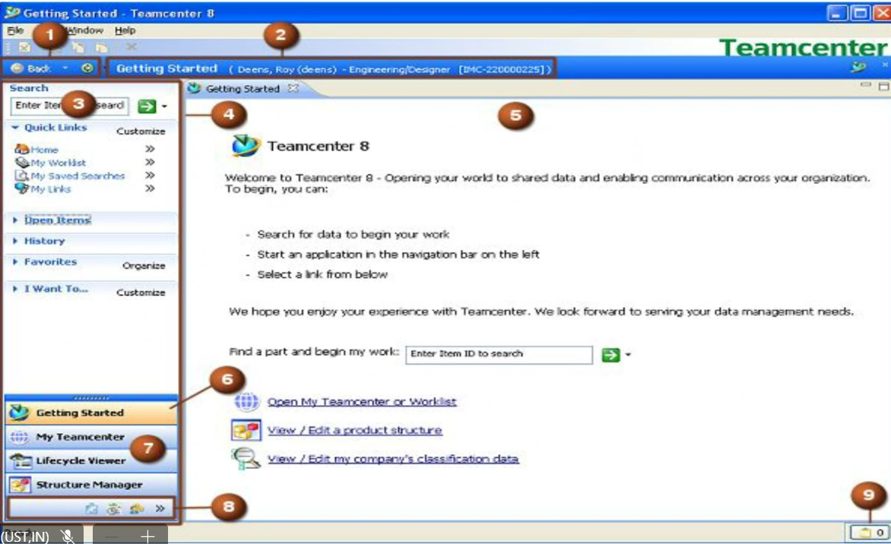
- Secondary Application

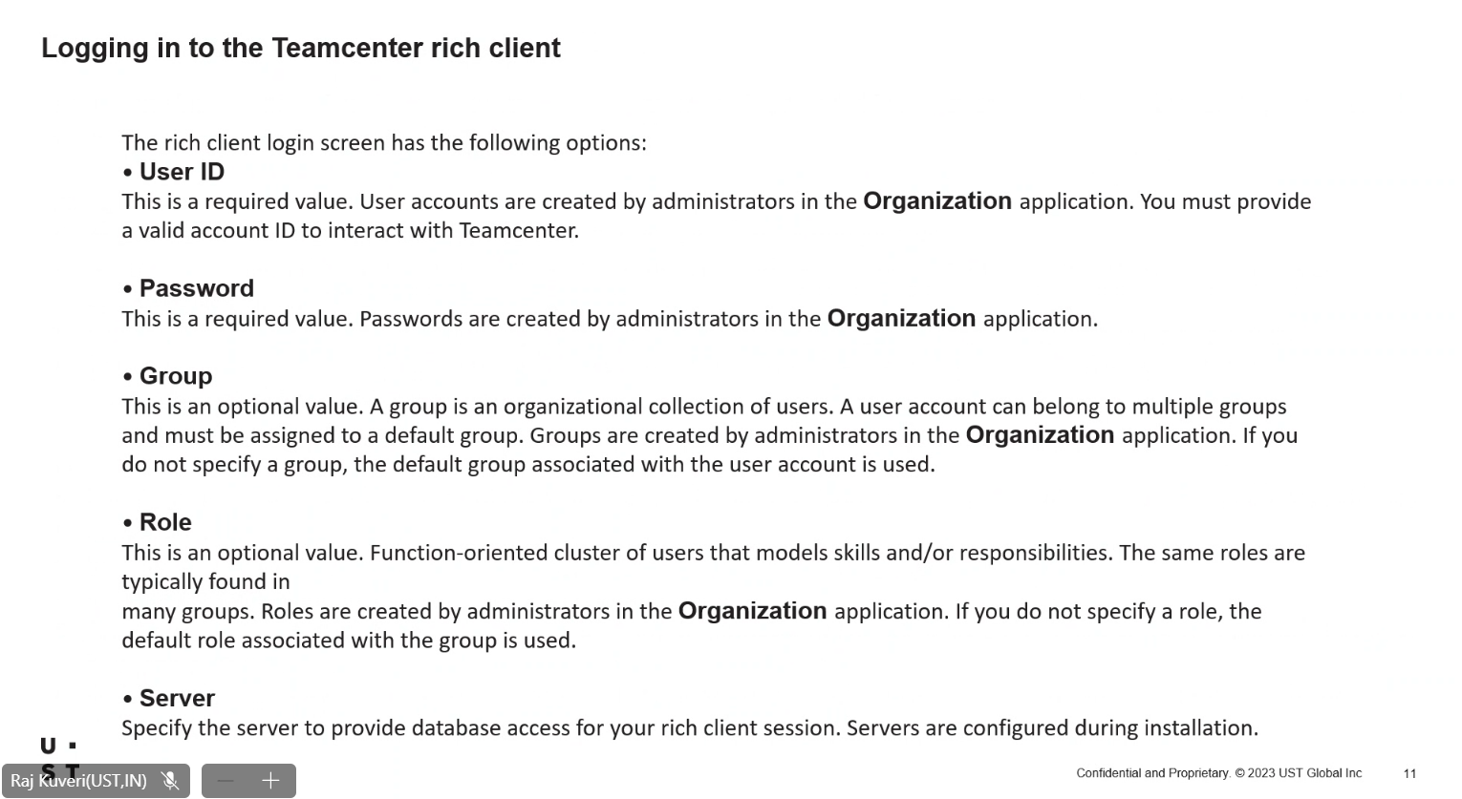

RAC -Rich Access Client

How to access Teamcenter cis log
Go to helpabout “Log File” or “cis file”
“Rich client log”

Searching in Teamcenter
Quick search – Feature in navigation menu lets you search for data by specifying the dataset name , item ID, name or keyword.
Advanced Search

-My saved search – contains queries that you previously and chose to save for later use.
- System defined searches – contains both standard queries and custom queries by Teamcenter admin
- search history – contains most recent queries. Admin can control how many to be shown.

Changing user settings
- This is usually done when the user has multiple roles.
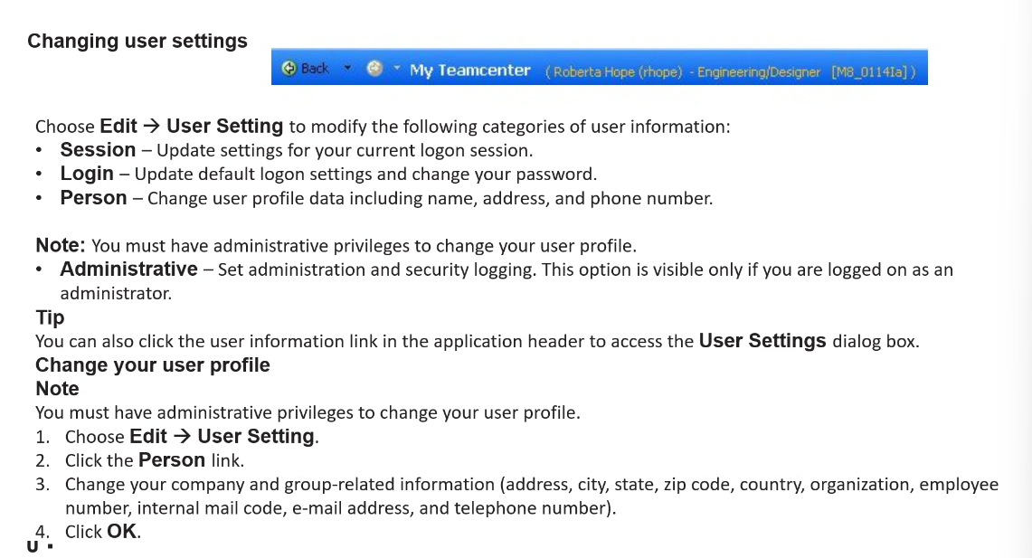

- Make User Utility
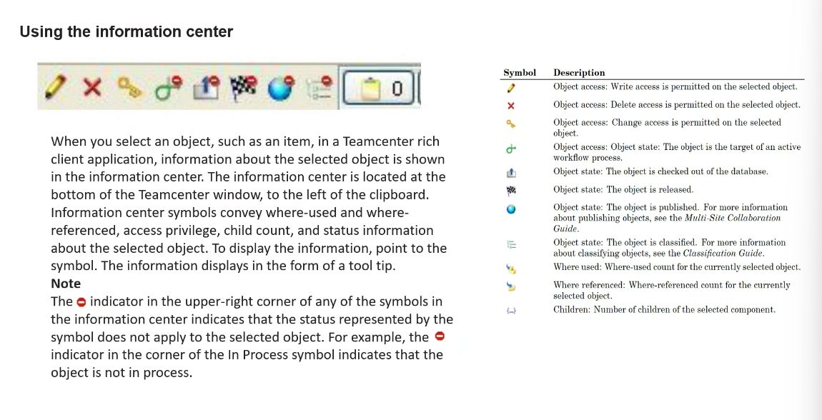
The user in different server wont be able to change the data since it’s a replica.
Remote checkout
When Teamcenter is opened my worklist also comes.

My Worklist
-only initiator can track it.

Impact Analysis
Where referenced form.
View TAB
- Summary
- Details
- Impact analysis
- Viewer
- JT Preview
Purging dataset

Friday 7th February
Deep Copy role
- Copy as an Object
- Copy as a reference
View and modify the object properties

BMIDE – used to configure Teamcenter
Item contains 2 names: -
- Original name (does not contain any spaces)
- Display name (can contain)
Edit option general folder and select UI System Admin
(Use to select between original and display name as preference)
(ONLY affect the user not the role)
Pseudo Folder
Transfer Checkout without checking out transfer it to different user
Checkout History
2 types of access
- Rule based access
- Object based access
Revision Rule

Team Center Architecture
What types of Architecture available in Teamcenter
What all clients are there in Teamcenter
What is FMS (File management system)

To start: fccstat -start
Go to teamcenter root and change to tccs folder. Bin directory Lauch cmnd
To check fcc status type the below command
fccstat -status
fccstat -stop To stop the service
till the tccs folder it is called fms home folder
FMS
TeamCenter extension will be .cislog

It will start with “tcserver.exe”
2-tier architecture
4-tier architecture

iiop servers

The old name for Teamcenter was iMAN (Integrated Manufacturing Information System) before it was rebranded by Siemens. It was originally developed by UGS (Unigraphics Solutions) before Siemens acquired UGS in 2007.

NX was originally called Unigraphics (UG). It was developed by McDonnell Douglas in the 1970s and later acquired by EDS (Electronic Data Systems).

Group is dba
Role is DBA
Pipe character “|” Used to separate arguments

ART ( Account Request Tool )

Suggestive LOV and Exhaustive LOV
2-tier
- Database server
- Volumes
- File server

4-tier
Additional applications
- Web tier
- Enterprise tier

